How To: Restore your iDevice from a Backup on iTunes
- iDevice: Your iPhone, iPod, or your iPad
- iTunes: Apple’s software that lets you manage and manipulate your iDevice according to your liking
Why Restore from a Backup?
Having a backup for your iDevice is crucial in case issues associated with your device. A primary example is losing your data due to an accidental reset or mistake. Along with the former, having a backup ensures that you are able to revert back to an older iOS firmware if deemed necessary.
CAUTION: YOU MUST HAVE YOUR iDEVICE BACKED UP BEFOREHAND TO PROCEED FURTHER
Items you’ll need:
- The computer containing your iPhone backup and an updated version of iTunes (Found at: https://www.apple.com/itunes/download/)
- The USB to iDevice cable that you got in the box with your phone (or an equivalent replacement)
- The iDevice in question with at least 50% charge
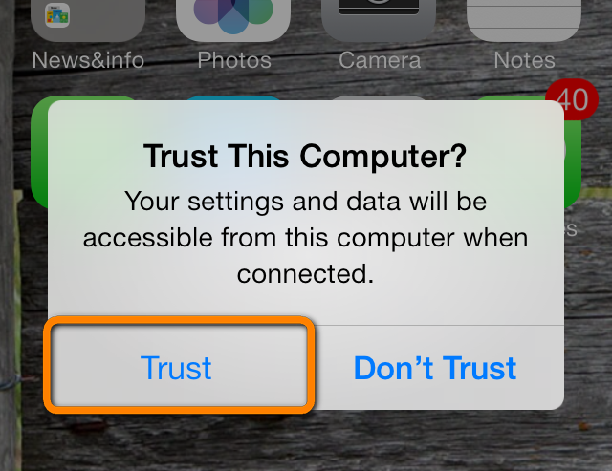
CAUTION: KEEP YOUR iDEVICE CONNECTED TO YOUR COMPUTER THROUGHOUT THE PROCESS
Procedure:
- Open iTunes on your computer
- Connect your iDevice in question to the computer
Figure 1, www.support.apple.com
- When the “Trust This Device?” prompt comes up, tap trust on both devices (Figure 1)
Figure 2
- You should now see the symbol for your iDevice pop up beneath the play/pause buttons in iTunes; Click on it! (Figure 2)

- On the info page for your iDevice (Figure 3) on iTunes, hit “Restore Backup…” (Figure 4)
- Choose the backup that you would like to restore from (Figure 5)
- Hit Restore
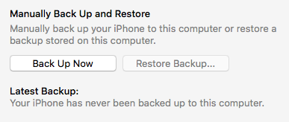
- Process should take 5-10 minutes and your device should restart during the process
Figure 3, www.support.apple.com
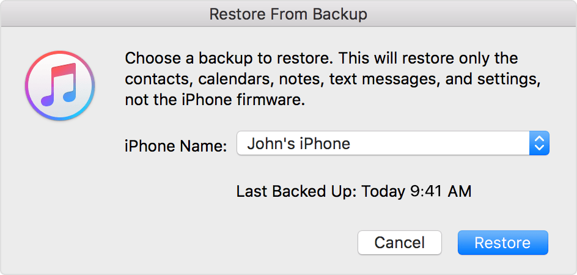
- Once your iDevice has restarted and synced with iTunes for the second time, you may disconnect your iDevice and resume normal usage (Figure 6)
Figure 4
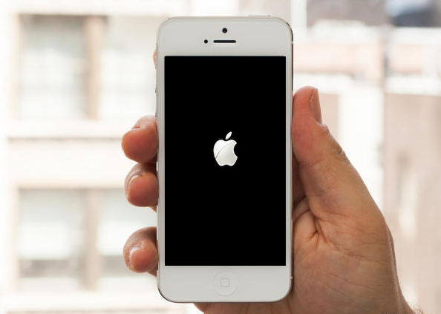
CONGRATS! You’ve successfully restored your iDevice from iTunes!
Figure 6, www.support.apple.com
Figure 5, www.support.apple.com

